MINI PROJECT I
HOSPITAL PATIENT ANALYTICS

AIM:
To analyze healthcare patient data using Python, SQL Server, and Power BI by preparing and managing patient records, performing data analysis, and creating interactive visualizations to identify trends in patient demographics, medical conditions, hospital admissions, treatment costs, insurance providers, and patient outcomes.
DOMAIN:
Healthcare Data Analytics and Business Intelligence
The project focuses on analyzing hospital and patient information to obtain useful insights that can support healthcare management and decision-making.
SOFTWARE AND TOOLS REQUIRED:
- Python
- VS Code / Jupyter Notebook
- Pandas
- Matplotlib
- SQL Server
- SQL Server Management Studio (SSMS)
- Power BI Desktop
- Microsoft Excel / CSV Dataset
- Windows Operating System
PROJECT WORKFLOW:
The overall project workflow is:
Healthcare Dataset
↓
Python Data Processing
↓
Data Cleaning and Preparation
↓
CSV Dataset
↓
Data Verification and Analysis
↓
Power BI Connection
↓
Charts and Visualizations
↓
Interactive Healthcare Dashboard
PROCEDURE:
- Download the healthcare dataset from Kaggle and save it as a CSV file.
- Import the dataset into Python using Pandas.
- Display the dataset and check its rows, columns, and data types.
- Check and handle missing or duplicate values.
- Calculate useful values such as patient age groups, length of stay, and billing amount.
- Save the cleaned dataset as a new CSV file.
- Create a database named healthcare_analytics in SQL Server.
- Create a table to store the patient data.
- Import the cleaned CSV dataset into SQL Server.
- Verify the number of records using SQL queries.
- Connect Power BI Desktop to the SQL Server database.
- Create charts for medical conditions, gender, admission type, insurance providers, billing amount, and test results.
- Add slicers for gender, medical condition, admission type, insurance provider, and test results.
- Arrange the charts and slicers to create an interactive healthcare dashboard.
- Analyze the dashboard to identify useful healthcare patterns and trends.
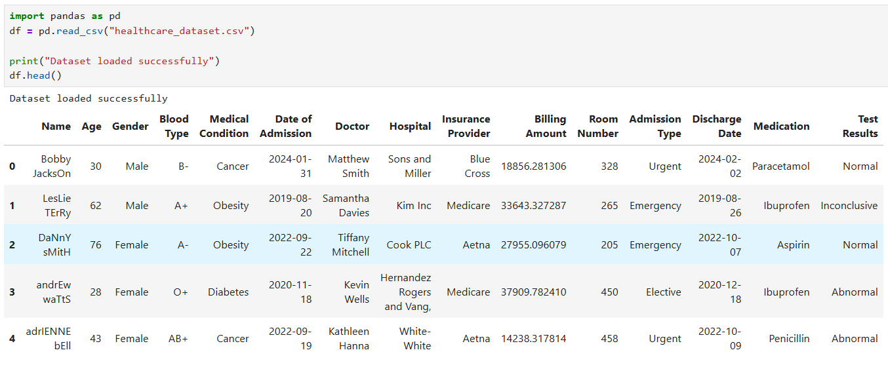
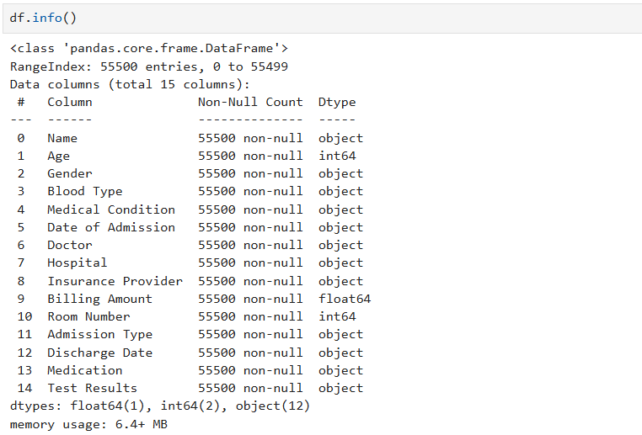
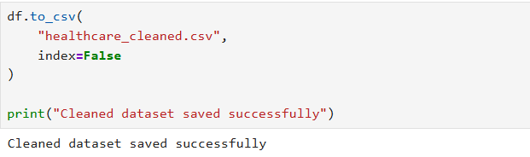

POWERBI DASHBOARD:
- Open Power BI Desktop.
- Select Home → Get Data → Text/CSV.
- Select healthcare_cleaned.csv.
- Click Load to import the cleaned healthcare data.
- Verify that all required columns are available in the Data/Fields pane.
- Open Report View to create the dashboard.
- Add a Card visual and use Name → Count to display Total Patients.
- Add another Card and use Billing Amount → Average to display Average Billing Amount.
- Add another Card and use Length of Stay → Average to display Average Length of Stay.
- Add a Bar Chart using Medical Condition and Name → Count to display Patients by Medical Condition.
- Add a Column Chart using Admission Type and Name → Count to display Patients by Admission Type.
- Add a Donut Chart using Insurance Provider and Name → Count to display Insurance Provider Distribution.
- Add a Bar Chart using Medical Condition and Billing Amount → Average to display Average Billing Amount by Medical Condition.
- Add a Column Chart using Test Results and Name → Count to display Patients by Test Results.
- Add a Slicer using Gender to filter patients by gender.
- Add another Slicer using Medical Condition to filter patients by medical condition.
- Arrange all the visualizations neatly on the report canvas.
- Add suitable titles to each visualization.
- Format the cards, charts, slicers, and dashboard layout for better readability.
- Test the slicers and verify that the charts update according to the selected values.
- Save the Power BI report as Healthcare_Analytics.pbix.
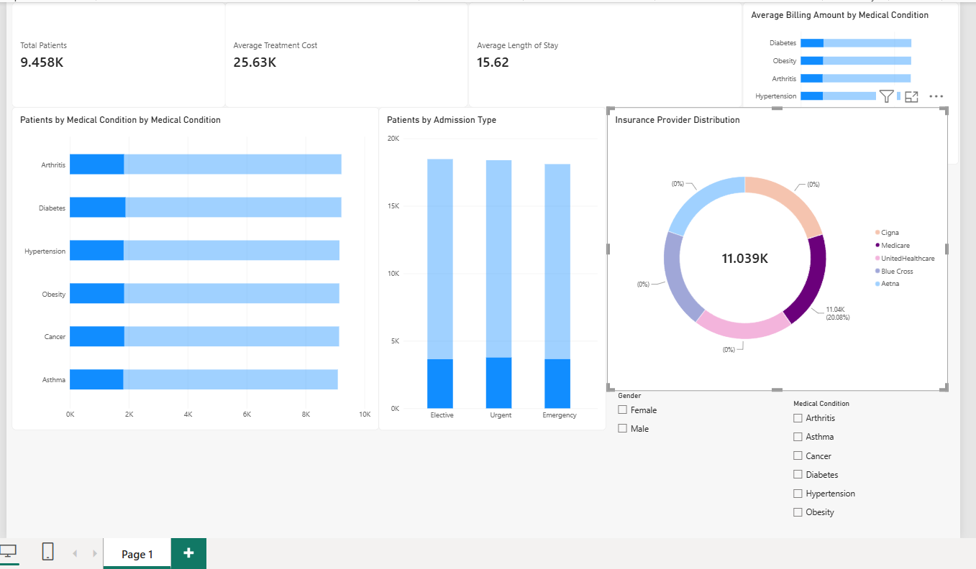
RESULT:
The healthcare dataset was successfully imported into Power BI and an interactive dashboard was created to analyze patient demographics, medical conditions, admission types, insurance providers, billing amounts, length of stay, and test results.

